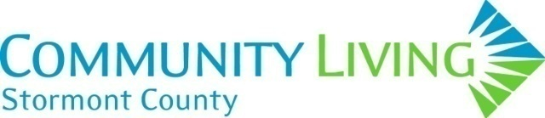 | Family/Guardian Feedback Survey
 | YEAR: 2024
Every two years C.L.S.C. takes this opportunity to hear from family members/Guardian to ensure our work is in line with our Mission, Vision, Values, and expectations.

Please complete the Feedback Survey by answering all the questions or just the ones you feel comfortable answering. We welcome your input and any questions you may have about our work.

Thank you!
SECTION #1
Developmental Services Ontario |  |  |  | YES | NO | N/A
- Are you aware Developmental Services Ontario Eastern Region – (DSOER) is the single point of access for Services and Supports for your son/daughter/sibling/other?
Contact Toll Free Number: 1-855-376-3737

SECTION #2
Please Check ONLY ONE box (YES or NO or N/A “Not Applicable”) when completing each of the questions.
 | YES | NO |  | N/A
- Are you aware of, and are you satisfied with, the Person-Centered Plan and Individual Support plan completed for your son/daughter/sibling/other?
COMMENTS:
 | YES | NO |  | N/A
- Are you satisfied that your son/daughter/sibling/other is supported in a safe living or community supported environment?
COMMENTS:
 | YES | NO | N/A
- Is your son/daughter/sibling/other given the opportunity to participate in community-based activities and use generic services to the best of his/her ability?
COMMENTS:
 | YES | NO | N/A
- Do you feel the Manager and staff, of the service provided to your son/daughter/sibling/other, are available to answer questions and share information as required?
COMMENTS:

 | YES | NO | N/A
- Are you satisfied with the service being provided to your son/daughter/sibling/other?
COMMENTS:

- What matters the very most to you about the supports your family member receives from Community Living-Stormont County?
COMMENTS:

- Please indicate how likely you would be to recommend Community Living-Stormont County as a place for other people to receive services?
□ Unlikely □ Likely

- What if anything could Community Living-Stormont County do to better support people and families? This could be changing an existing service, or something else entirely. What challenges or obstacles could get in the way?
COMMENTS:

- If there is anything you think Community Living-Stormont County should keep in mind through the Strategic Planning Process, please share your thoughts.
COMMENTS:

OTHER | YES | NO | N/A
- Would you be interested in being a part of a family group?
If so, please contact us at: 613-938-9550 Ext 241
- Have you been involved in meetings when it comes to advocacy?
If so, what types of meetings?

On behalf of Community Living-Stormont County, we thank you for taking the time to complete this survey. Your feedback will help us to provide the best possible services and supports.

