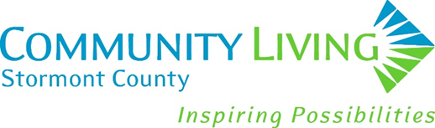

Community Living Stormont County Strategic Plan
2025-2028

INTRODUCTION

On Saturday, October 19, 2024, Community Living Stormont County (CLSC) held a one-day strategic priority setting session involving the Board of Directors, the Executive Director, and the management team. The session was designed and facilitated by People Minded Business consultants. The purpose of the day was to have the group review current and emerging societal and developmental services trends and other topics relevant to the organization’s future to determine relevant strategic priorities that when addressed will position CLSC for success and sustainability moving forward. Importantly, the group also identified CLSC’s many assets and strengths, that will be tapped into to keep momentum moving forward. Setting aside time to think about and discuss where to direct the organization’s resources was intentionally timely, as the DS sector is going through significant reform which involves assessing the ways in which CLSC ought to be structured and operate to align with its primary funder, the Ministry of Children and Community Social Services’ Journey to Belonging framework.

STRATEGIC PRIORITIES AND RELATED GOALS

Strengthen Capacity and Capabilities to Ready CLSC for DS Reform
- Educate all employees, unions, families, and people supported about MCCSS Developmental Services Reform ~ Journey to Belonging and ways CLCS will align supports and services for positive impacts.
- Involve employees across CLSC in co-designing needed improvements to internal operations.
- Engage in marketing, communications, and public relations to ensure CLSC is known and well positioned as a preferred service provider in Stormont County.

Build a Skilled and Sustainable Workforce for the Future
- Develop a formal succession and knowledge transfer plan.
- Continue to explore creative ways to recruit, retain, and train employees.
- Apply a diversity, equity, and inclusion lens when recruiting new employees and training all.
- Use technology to support the effectiveness and efficiencies of CLSC’s work.

Expand Funding Streams for Long-Term Sustainability
- Devise strategies to increase passport funding utilization and private fee-for-service.
- Explore a social enterprise start-up that aligns with the interests of people receiving supports.
- Engage in additional fundraising.
- Seek out a wide range of grant opportunities.

Advance Current Service Offerings to Meet Current and Emerging Needs
- With the direct involvement of people and families, explore and pilot:
  - New housing arrangements
  - Innovative respite/short break options
  - Partnering opportunities.

